Unit 5 - Lesson 3 - Tender Response & Evaluation Criteria
Lesson 3 of 3

Lesson Objectives
At the end of this lesson, you will be able to:
Understand Tender Responses and Evaluation Criteria
⧉ Audio placeholder (00:12) — no local audio matched this placeholder

Evaluation Criteria
The systems to support this evaluation and acceptance processes are:
- Project procurement
- BIM execution plan
- I.M competency assessments
- Capability and capacity summary
- Information risk register
- Mobilization plan
Audio transcript (01:13)
The appointing party shall use a set of criteria typically defined in the EIR to either accept or reject the information. Typically evaluation considerations could be grouped under the following sections, price, understanding of the requirements, compliance with ITT requirements, technical skills, resource availability, management skills and systems, proposed methodology. Price is not part of the IM portion of the ISO as the information procurement appointment should be integrated into the project procurement and it is the project procurement that will consider price. The BIM execution plan can be used to consider whether the delivery team has understood the requirements. A completed tender return or checklist system will confirm compliance. The appointing party needs to evaluate the competency for the IM function. The delivery team capability and capacity summary can be used to consider whether the delivery team has the skills and resources available. The BIM execution plan and information delivery risk assessment can be used to consider whether the delivery team has acceptable management skills and systems in place. The mobilization plan is how you're going to test your proposals work. This can be used to consider whether the delivery team has provided an acceptable methodology.
Source audio: Lesson 3 - Tender Response Evaluation Criteria - BIM ISO 19650 1.mp3

Compile Invitation to Tender Information
The appointing party shall assemble the invitation to tender package.
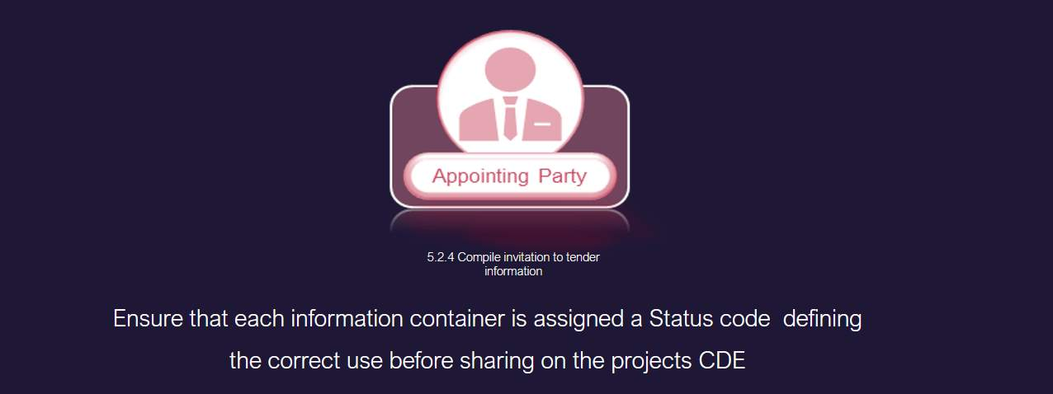
⧉ Audio placeholder (00:15) — no local audio matched this placeholder

Invitation to Tender Activities
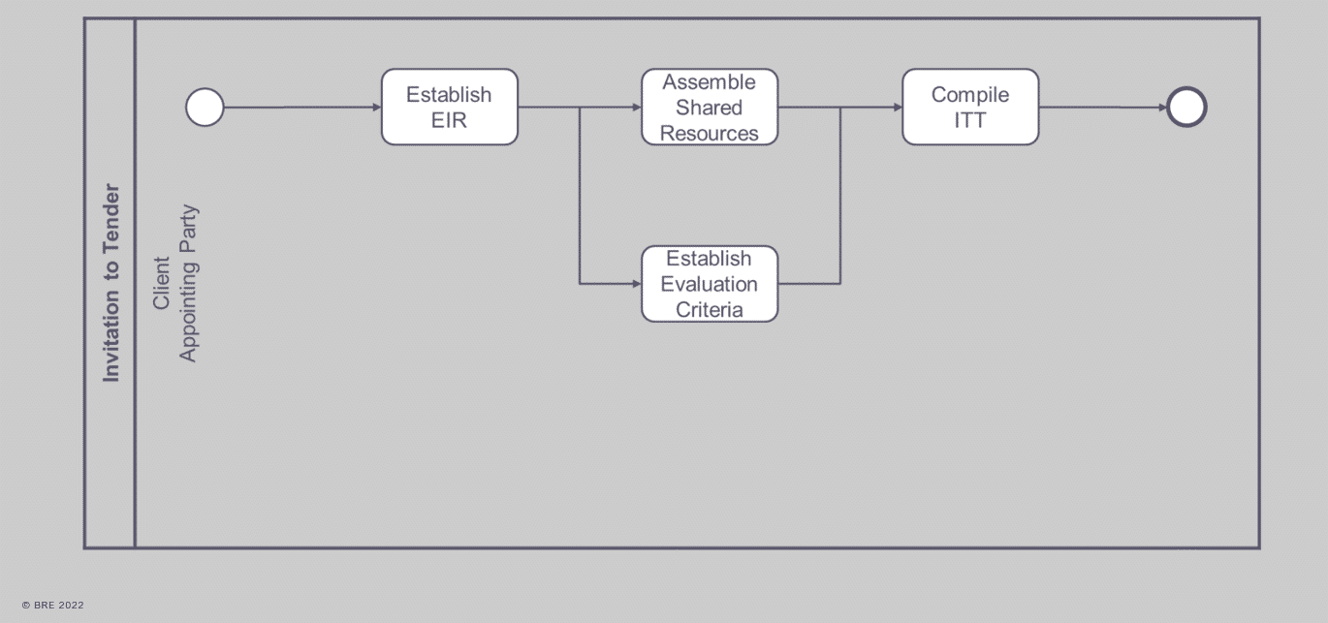
Summary of ITT or invitation to tender activities
The appointing party needs to:
Establish EIRAssemble Shared ResourcesEstablish Evaluation CriteriaAnd then compile the ITT

Learning Summary
Lesson complete! You are now able to:
Understand Tender Responses and Evaluation Criteria

Unit 5 Complete!
Module Complete, you may now close the window and complete this module.

